# Mobile Use-Case Outline (Jeremiah Doody)

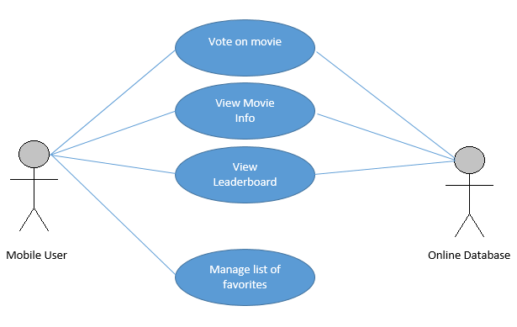

# Mobile Voter chooses to vote on a movie

## Brief Description

The mobile voter goes to the voting page of the app and enters their vote for the block.

## Basic Flow of Events

### Mobile voter chooses option from main page to vote

### Mobile voter chooses the movie they want to vote for.

### The data is sent to database and the system tells the mobile voter the vote went through.

### The system returns the mobile voter to the main screen.

## Alternative Flows

### Mobile voter quits voting process by decision.

### Mobile voter is asked for demographics.

### The app exits during a vote (regardless of mobile voter intent).

## Subflows

None

## Scenarios

Mobile voter enters their vote for a movie – basic flow

Mobile voter enters their vote, and is prompted for mobile voter demographics. They fill it out and go to home – A1 alternate flow.

Mobile voter enters their vote, and is prompted for mobile voter demographics. They don’t fill it out and quit to home – A2 alternate flow

The mobile voter begins entering data and the app quits due to power failure, or something else. The vote doesn’t go through. A3 – alt Flow

# Mobile Voter chooses to view info on current movies

## Brief Description

The mobile voter requests to opens a screen with brief information on the movies currently playing at the film festival, which the system brings up.

## Basic Flow of Events

### Mobile voter enters input requesting a page with a list of movies on it.

### The mobile scrolls through the available movies.

### The mobile voter views the basic info provided.

### The mobile voter requests to return to the start screen.

## Alternative Flows

### Mobile voter chooses to watch a preview video of the movies provided.

### The mobile voter adds a movie to their “watched list.”

### The mobile voter adds a movie to their favorites.

### The app quits during page load.

## Subflows

None

## Key Scenarios

Mobile voter views info on movies – basic flow

Mobile voter views extra info on movie, such as preview video. – A1 alternate flow.

The mobile voter adds a movie to their watch later list. A2 alternate flow

Mobile Voter leaves screen before screen loads. A1 alternate flow

The app quits due to power failure, or something else. App crashes. A2 – alt Flow

# Mobile Voter chooses to view leaderboard

## Brief Description

The mobile voter requests to open the leaderboard screen

## Basic Flow of Events

### Mobile voter presses on screen to view current leaderboard.

### The system pulls up a screen overlaying most of the main page.

### The mobile voter views the info.

### The mobile voter presses the return-to-main-page hotspot.

## Alternative Flows

### The mobile voter adds a movie to their watch list.

### The app quits during page load.

## Subflows

None

## Key Scenarios

Mobile voter views leaderboard info– basic flow

Mobile voter cannot view info. – Alt Flow 1

# Mobile voter manages a list of their favorites

## Brief Description

The mobile voter requests a page where they add a movie to a list of favorites.

## Basic Flow of Events

### Mobile voter presses on hotspot on main page to view their favorites.

### The system pulls up a screen overlaying the main page.

### The mobile voter views a list of their favorites.

### The mobile voter presses the return-to-main-page hotspot.

## Alternative Flows

### The mobile voter adds a movie to their “watched list.”

### The mobile voter removes a movie from their favorites.

### The mobile voter adds a movie back onto their favorites list.

### The app quits during page load.

## Subflows

None

## Key Scenarios

Mobile voter views their favorites – basic flow

Mobile voter adds movie to their “watched list” – Alt Flow 1

Mobile Voter removes movie from favorites. – Alt Flow 2

Mobile voter cannot manage favorites. – Alt Flow 4

Good!